MONARCHY MOTOR INSURANCE POLICY PROJECT

Introduction :
The Monarchy Motor Insurance System is a database management system developed using MySQL to automate the process of motor insurance policy management. The system stores customer, vehicle, broker, insurance product, premium, payment, and policy details in a structured database.
The application simplifies the insurance workflow from customer registration to policy generation while ensuring data consistency using relational database concepts.

Objectives :
• Store customer information.
• Maintain vehicle details.
• Manage insurance products.
• Calculate insurance premium.
• Generate insurance quotes.
• Process payments.
- Generate insurance policies.
• Maintain policy schedules.
• Record credit and debit notes.
• Demonstrate advanced MySQL concepts.

Modules
Module 1
Database & Master Setup
Tables
    - MMI_MAKE
    - MMI_MODEL
    - MMI_BODY
    - MMI_CATEGORY
    - MMI_COLOR
    - MMI_REGION
    - MMI_STATE
    - MMI_CITY

Module 2
User & Vehicle Management
Tables
    - MMI_USER_ROLE
    - MMI_USER
    - MMI_LOGIN
    - MMI_BROKER
    - MMI_CUSTOMER
    - MMI_VEHICLE

Module 3
SQL Operations
Topics
    - ALTER TABLE
    - UPDATE
    - DELETE
    - GROUP BY
    - HAVING
    - JOINS

Aggregate Functions :

Module 4
Product Management
Tables
    - MMI_PRODUCT
    - MMI_COVERAGE
    - MMI_PREMIUM_RATE

Module 5
Quote Management
Tables
    - MMI_QUOTE
    - MMI_QUOTE_DETAIL

Module 6
Payment & Policy
Tables
    - MMI_PAYMENT
    - MMI_POLICY
    - MMI_POLICY_SCHEDULE
    - MMI_CREDIT_NOTE
    - MMI_DEBIT_NOTE

Module 7
Advanced SQL
Topics
    - Stored Procedure
    - Function
    - Trigger
    - Event Scheduler
    - Index
    - Create User
    - Grant
    - Revoke
    - Transaction

5. SQL Concepts Used

    - DDL
    - DML
    - DQL
    - TCL
    - JOIN
    - GROUP BY
    - HAVING
    - SUBQUERY
    - VIEW
    - INDEX
    - PROCEDURE
    - FUNCTION
    - TRIGGER
    - EVENT
    - GRANT
    - REVOKE
CREATING THE DATABASE :
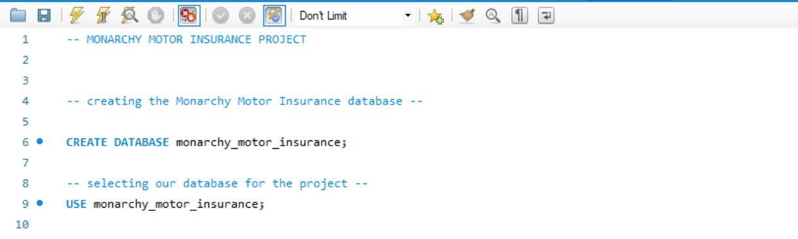
Creating the MMI_MAKE TABLE and inserting the records :
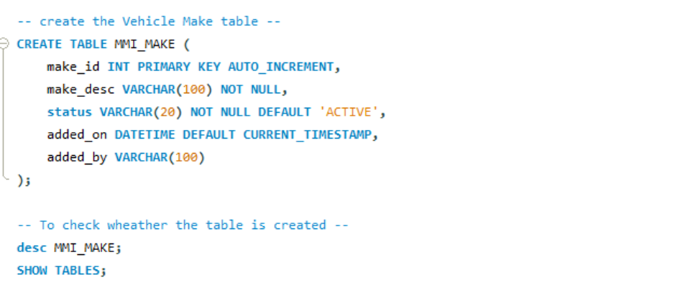
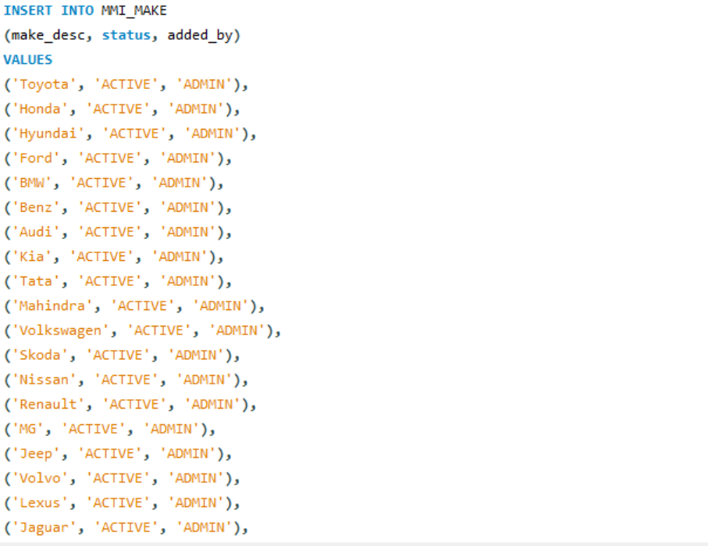
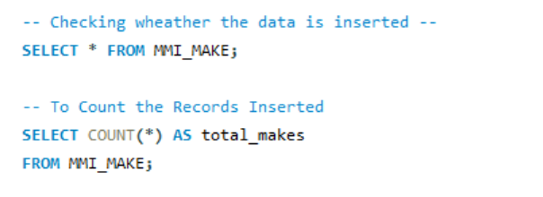

Creating MMI_MODEL TABLE and inserting the records 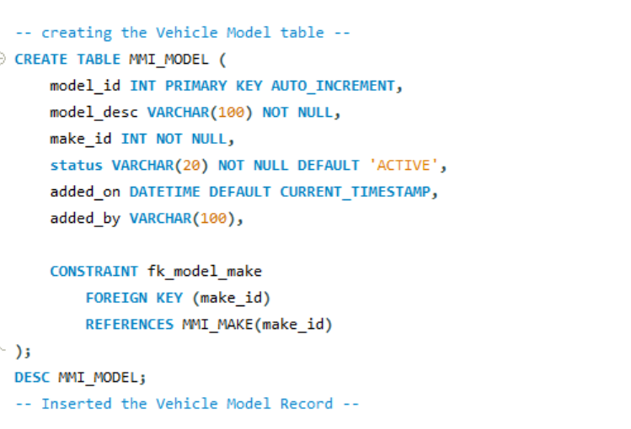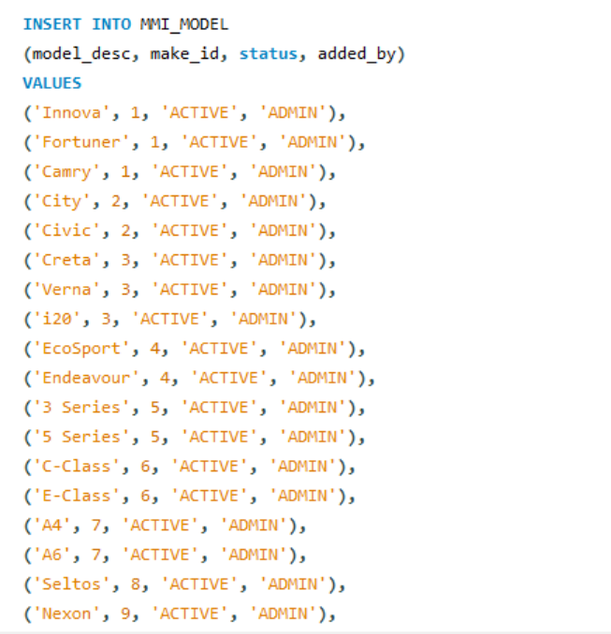
Displayed the MMI_MAKE and MMI_MODEL table together :
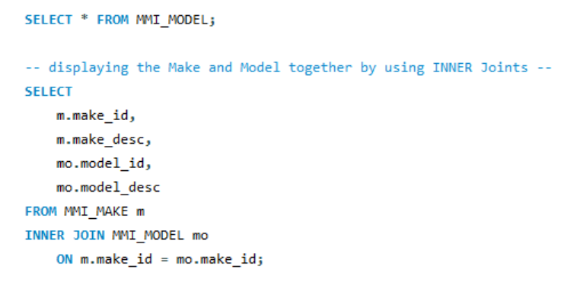

Creating the MMI_Body Table and Inserting the Records :
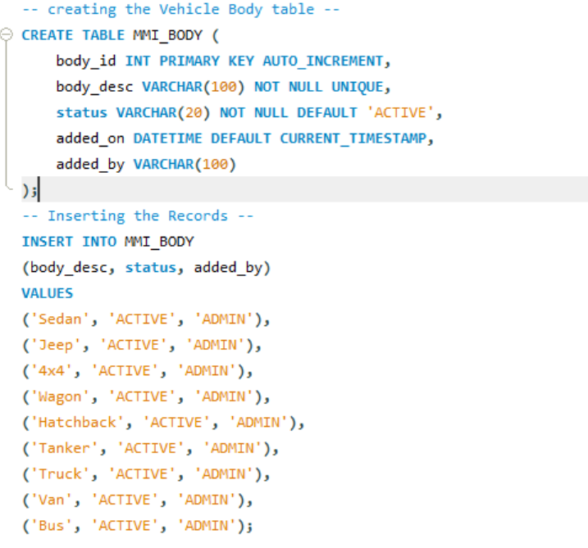

Creating the MMI_CATEGORY table and the MMI_COLOR and Inserting the Records :
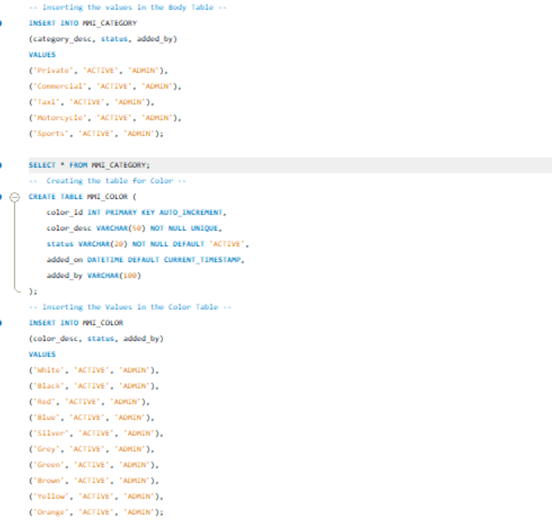
Creating the MMI_REGION TABLE and Inserting the Records :
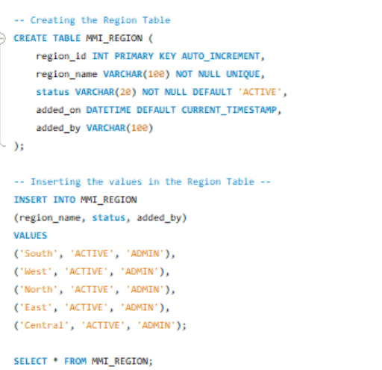
Creating the MMI_STATE table and Inserting the Records :
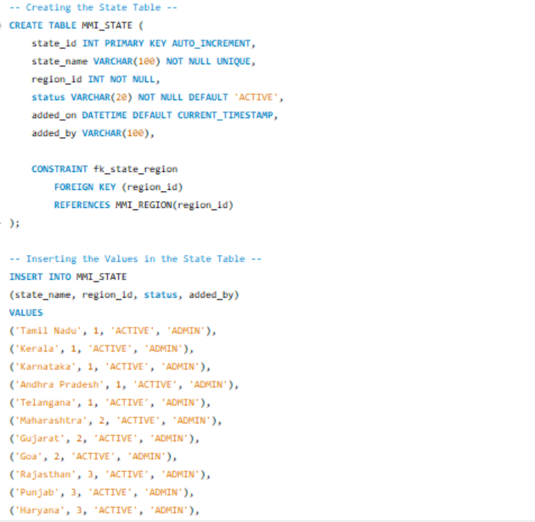
Creating the MMI_CITY table and Inserting the Records :
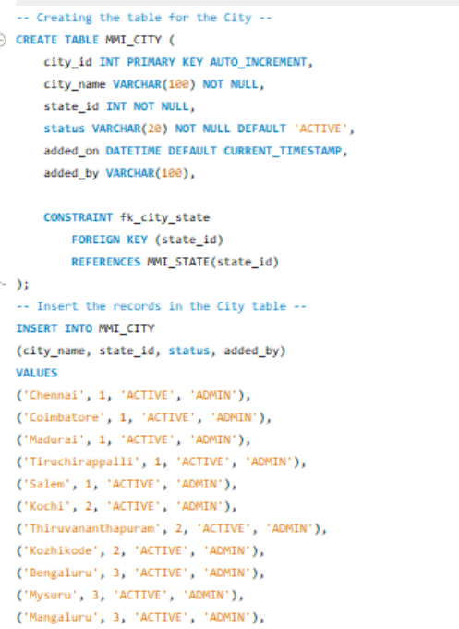

Display Region, State, and City together by INNER JOIN and also using the ORDERBY :
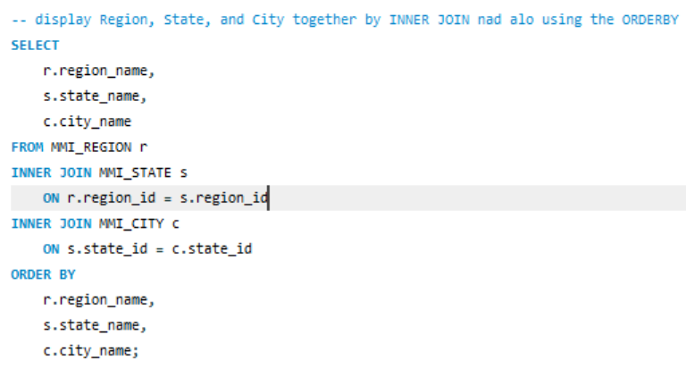
USER MANAGEMENT MODULE :
Creating the USER_ROLE table and Inserting the Records :
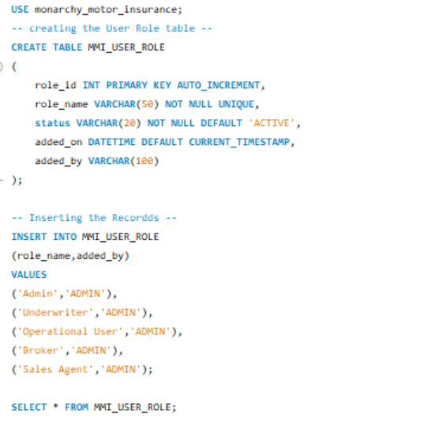

Creating the USER Table and Inserting the Records :
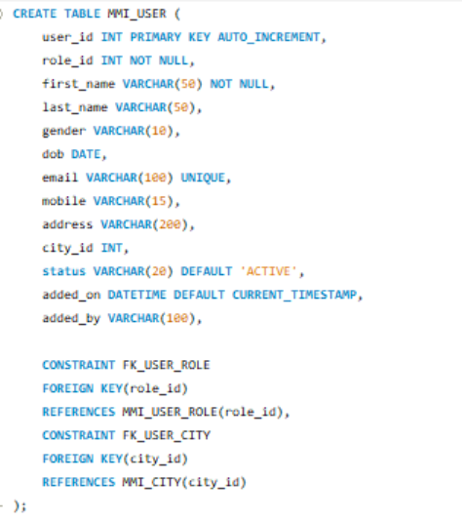
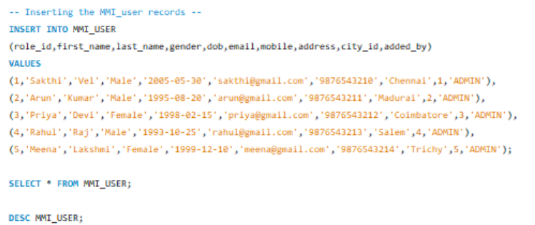

Creating the LOGIN Table and Inserting the Records :
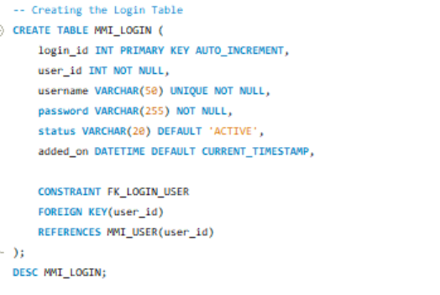
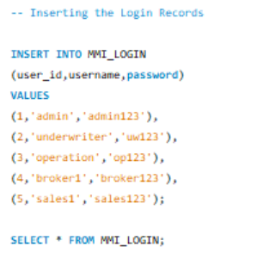
Creating the MMI_BROKER table and Inserting the Records :
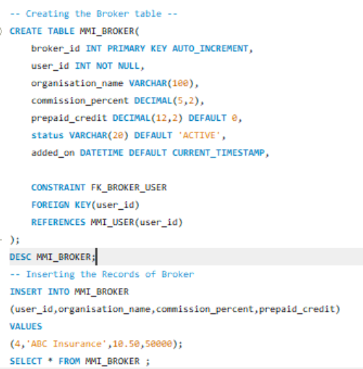
CREATING THE MMI_CUSTOMER Table and Inserting the Records :
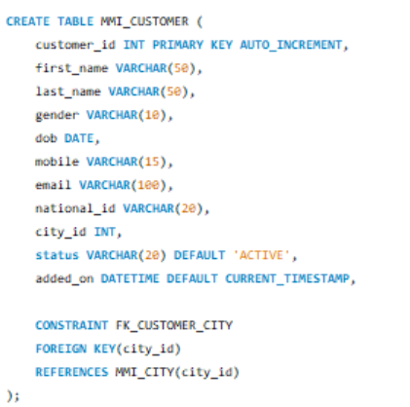

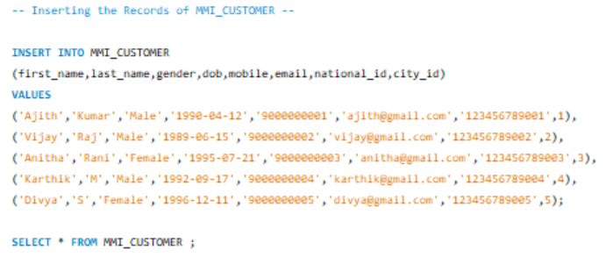
Creating the Vehicle Table and Inserting the Records :
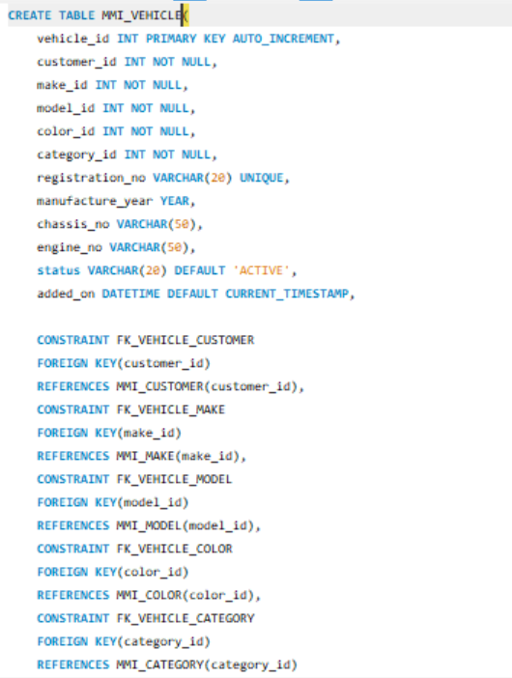
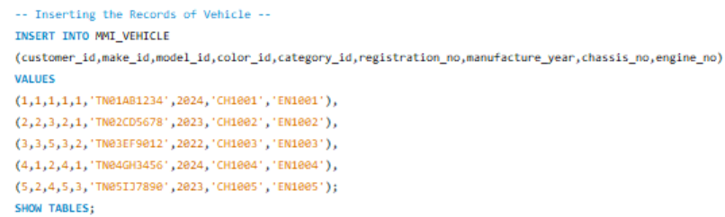
Add , Modify , Rename , Drop the Columns using the ALTER KEYWORD :
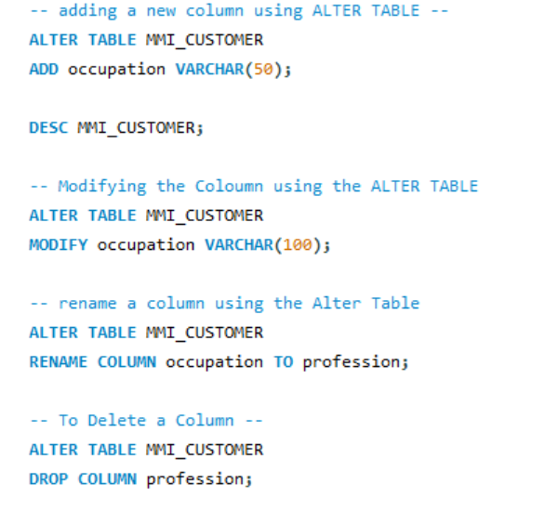
Update the Column using UPDATE keyword also multiple Clumns can be Updated and Delete the particular column or Delete the Entire Table using the DELETE keyword :
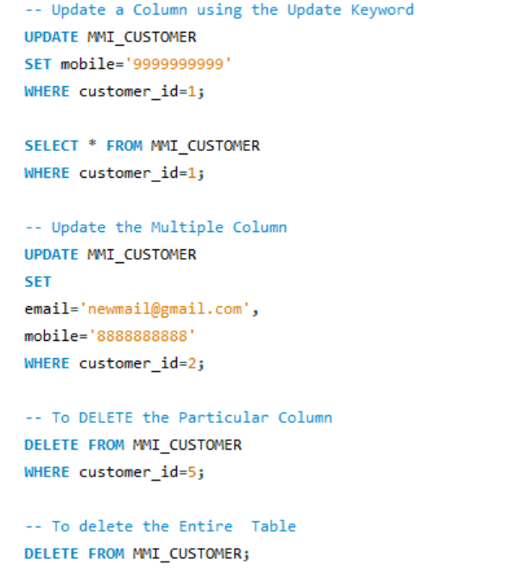

Using the AGGREGATE Functions like Count , Average , Min , Max :
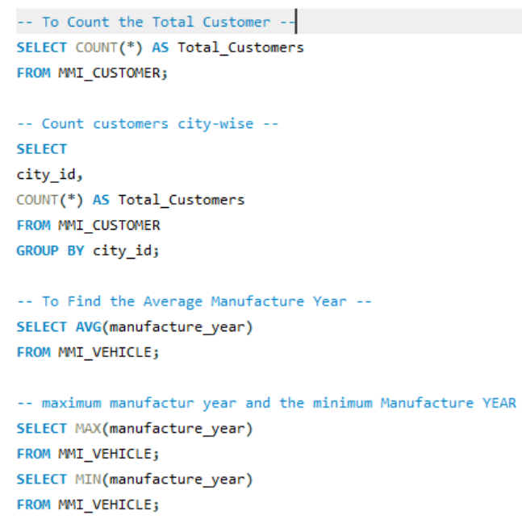
Using GROUP BY , HAVING , JOINTS :
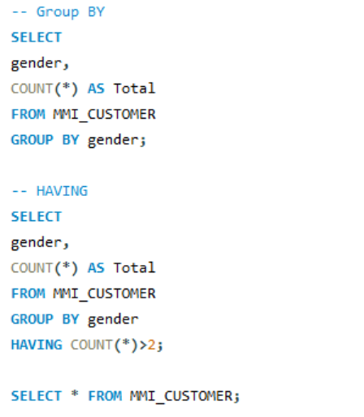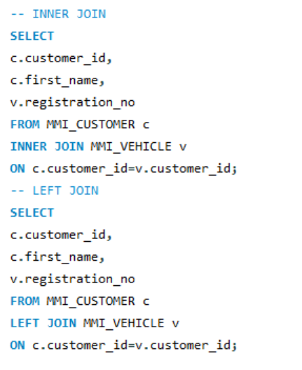
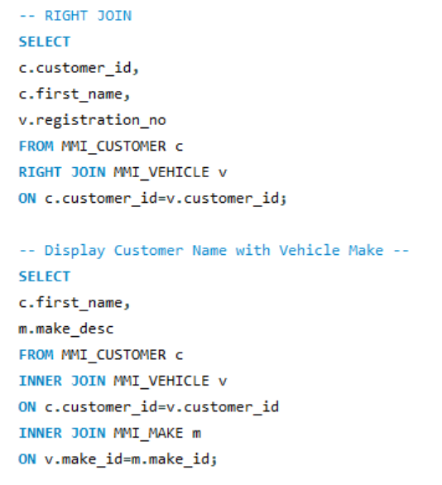
Creating the Product Table and Inserting the Records :
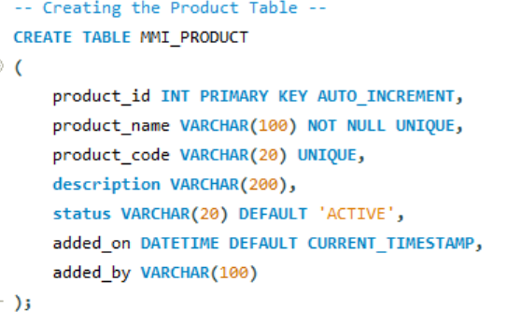
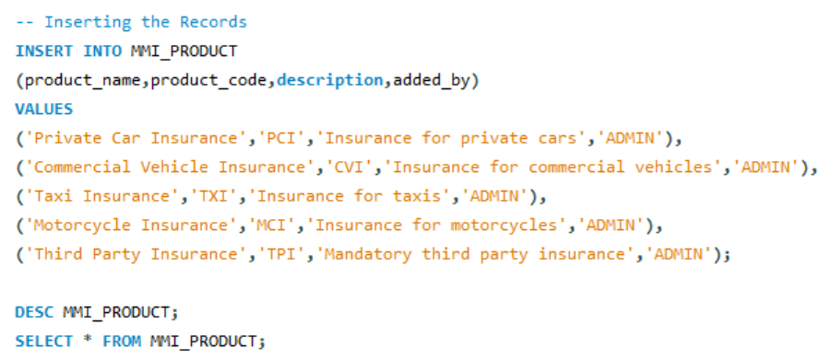

Creating the Coverage Table and Inserting the Records :
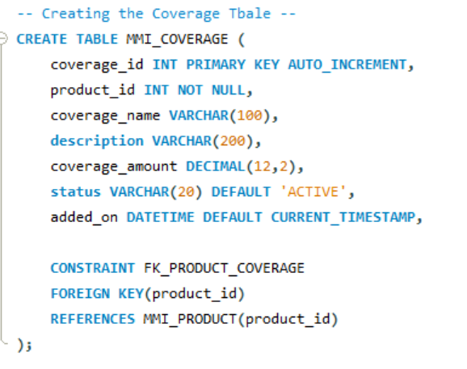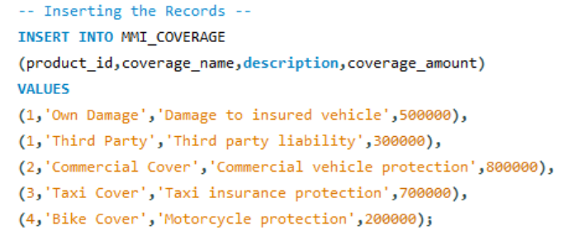
Creating the Premimum Rate Table and Inserting the Records :
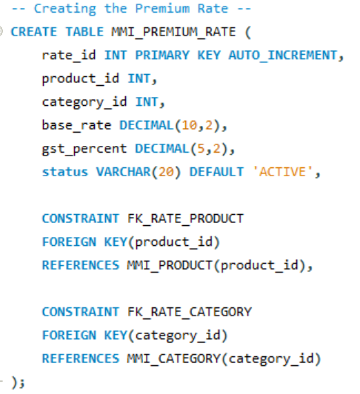
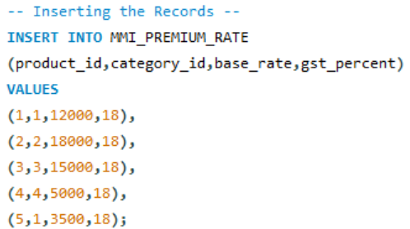
Displaying the Product with Coverage and also the Premium Retail Details :
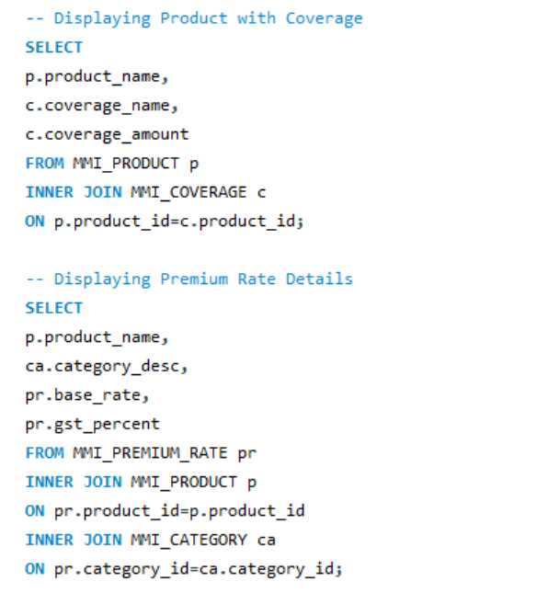
Creating the MMI_QUOTE Table and the Inserting the Records :
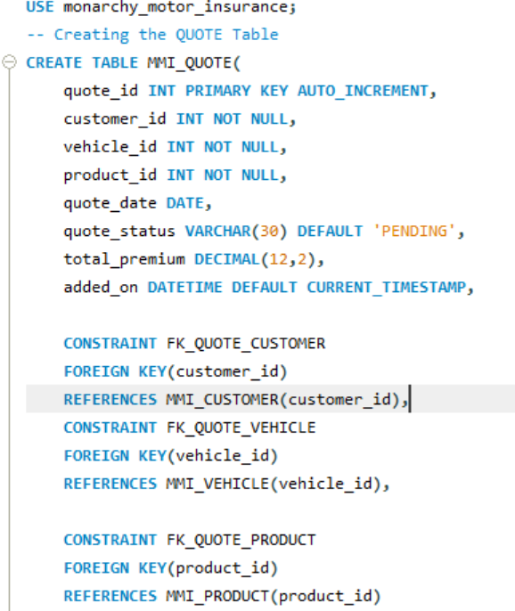
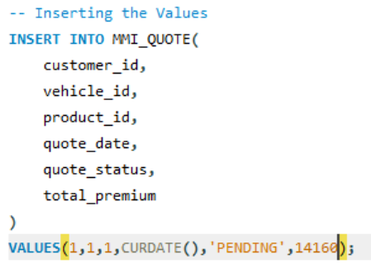
Creating the Quote details Table and Inserting the Records :
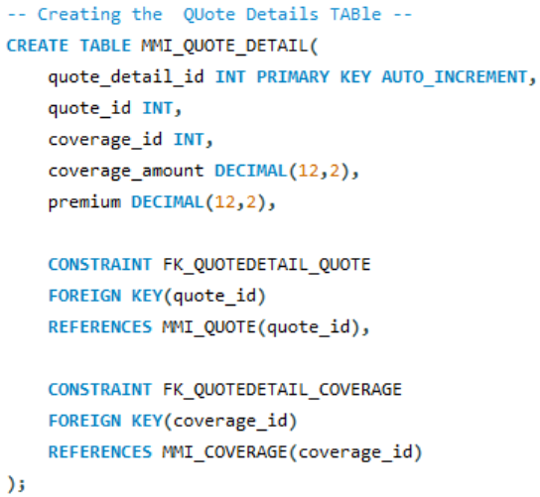
Displaying the Quote Information :
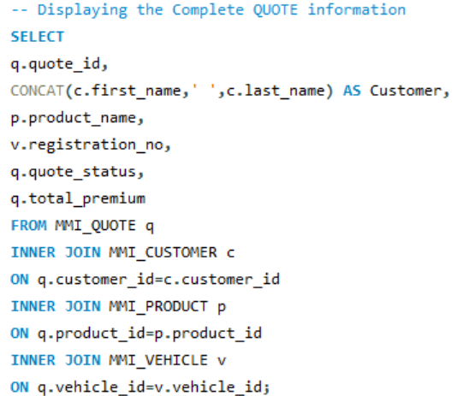

Display Customers whose Premium is greater than the Average Premium by using SUBQUERY :
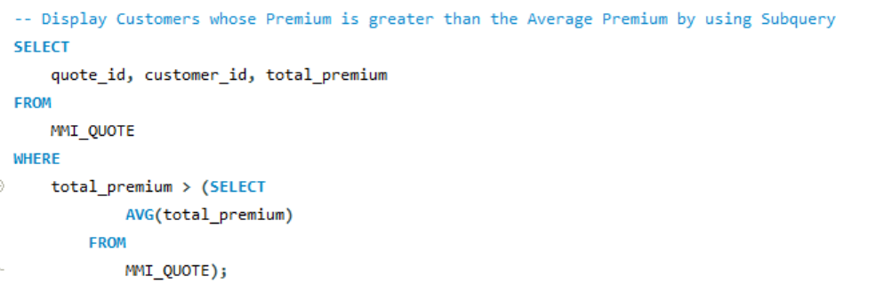
Customers who selected Private Car Insurance :
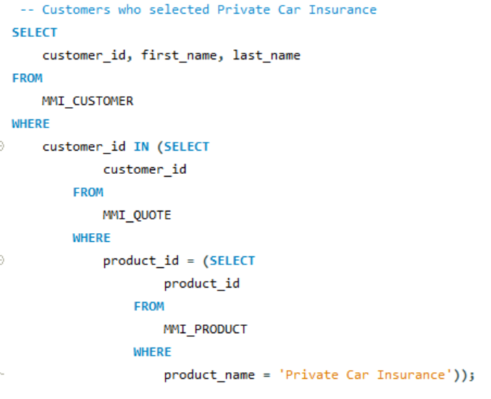

Creating the Payment Table and Inserting the Records :
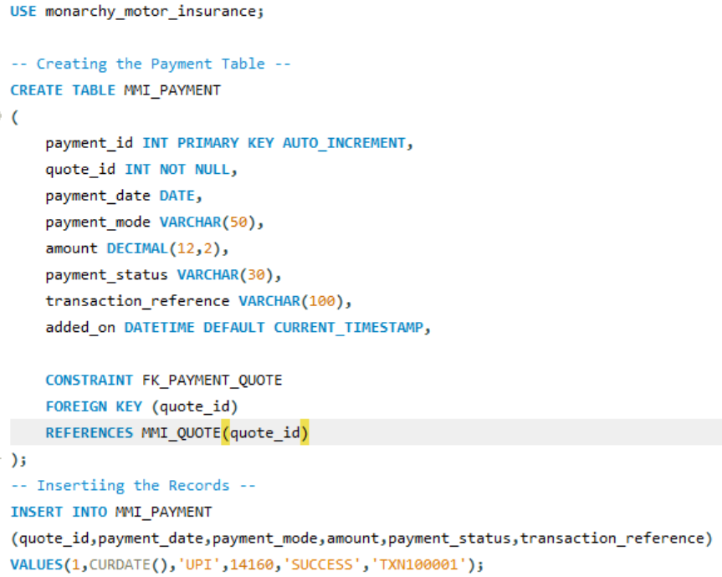
Creating the Policy table and Insert the Records :
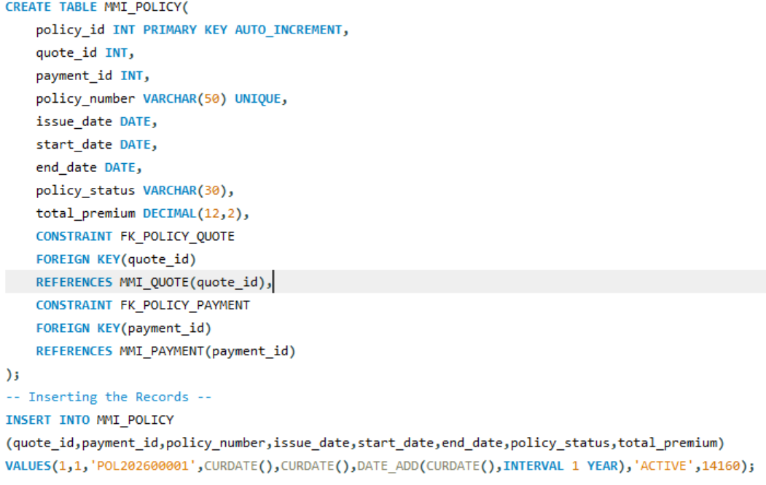
Creating the Policy Schedule Table and Inserting the Rcords :
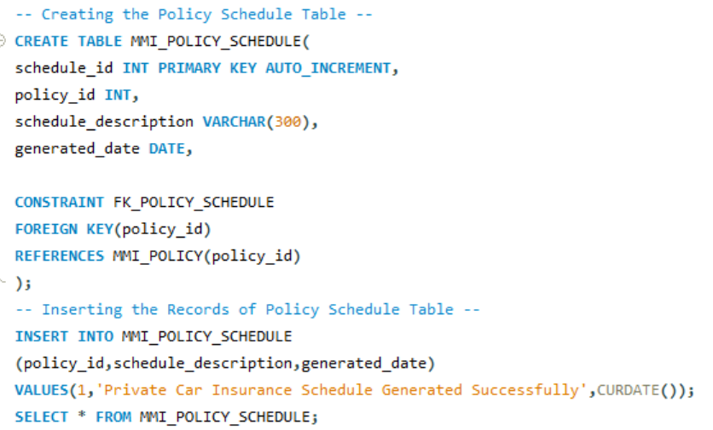
Creating the Credit Note Table and Inserting the Records :
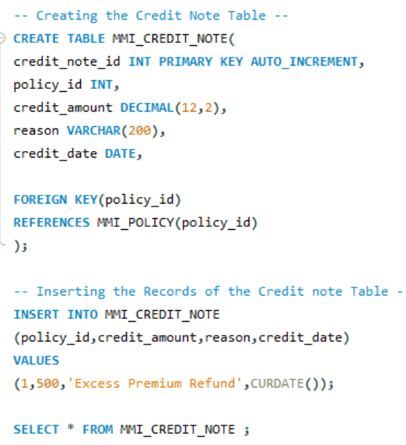
Creating the DebitNote Table and Inserting the Records :
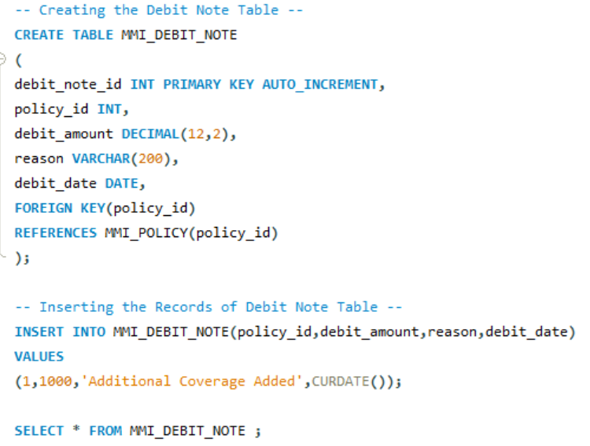

STORED PROCEDURE :
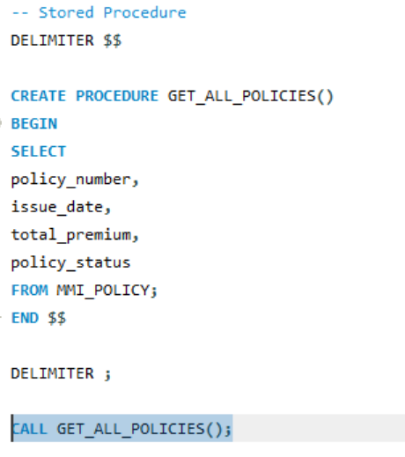

FUNCTIONS :
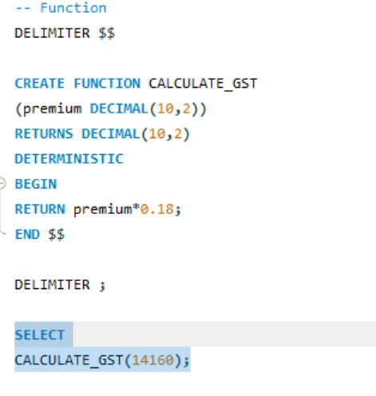
COMMIT & ROLLBACK :
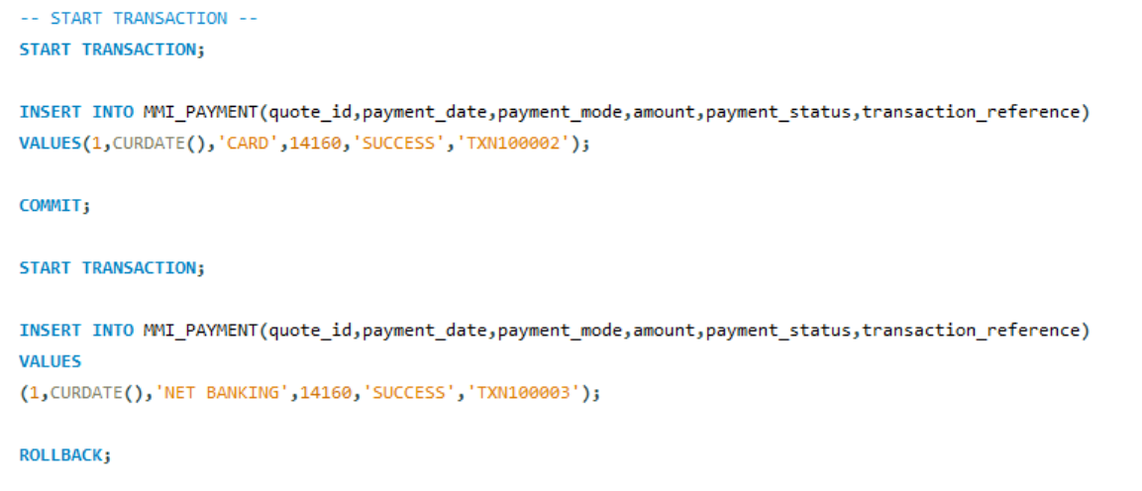

Creating the MMI_POLICY_AUDIT Table :
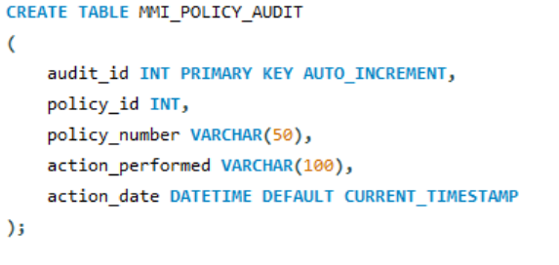
TRIGGERS :
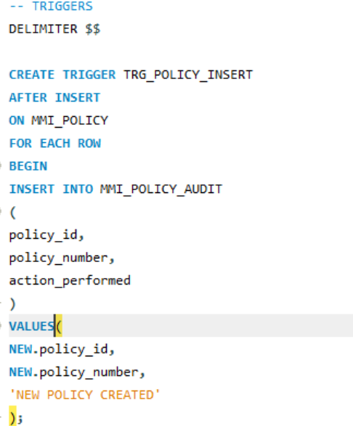
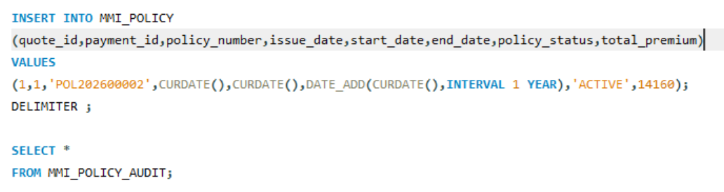

EVENT SCHEDULER :
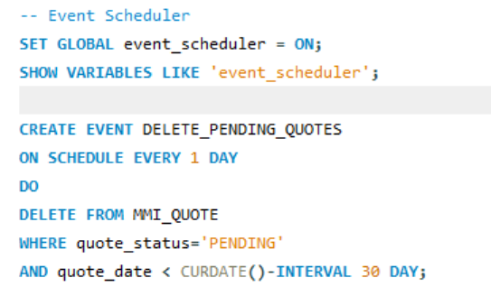
INDEX :
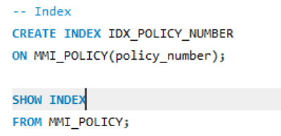
Creating the User to check the GRANT and REVOKE :
